**Exercise 1: Control Structures**

**Scenario 1:**

**For this scenario the customer table have to create:**

CREATE TABLE customers (

customer_id NUMBER PRIMARY KEY,

name VARCHAR2(100),

age NUMBER,

balance NUMBER(12,2),

is_vip CHAR(1) DEFAULT 'N' -- 'Y' = Yes, 'N' = No

);

//pl/sql code

SET SERVEROUTPUT ON;

BEGIN

FOR cust_rec IN (SELECT customer_id FROM customers WHERE age > 60) LOOP

FOR loan_rec IN (

SELECT loan_id, interest_rate FROM loans

WHERE customer_id = cust_rec.customer_id

) LOOP

UPDATE loans

SET interest_rate = loan_rec.interest_rate - 1

WHERE loan_id = loan_rec.loan_id;

DBMS_OUTPUT.PUT_LINE(

'Loan ID ' || loan_rec.loan_id ||

' for Customer ' || cust_rec.customer_id ||

' updated: ' || loan_rec.interest_rate || '% -> ' ||

(loan_rec.interest_rate - 1) || '%'

);

END LOOP;

END LOOP;

COMMIT;

END;

/

**Scenario 2:**

SET SERVEROUTPUT ON;

BEGIN

FOR cust_rec IN (SELECT customer_id, name, balance FROM customers WHERE balance > 10000) LOOP

UPDATE customers

SET is_vip = 'Y'

WHERE customer_id = cust_rec.customer_id;

DBMS_OUTPUT.PUT_LINE(

'Customer ' || cust_rec.name ||

' promoted to VIP. Balance: $' || cust_rec.balance

);

END LOOP;

COMMIT;

END;

/

**Scenaio 3:**

-- Loan Table

CREATE TABLE loans (

loan_id NUMBER PRIMARY KEY,

customer_id NUMBER REFERENCES customers(customer_id),

interest_rate NUMBER(5,2),

due_date DATE

);

//pl/sql code

SET SERVEROUTPUT ON;

BEGIN

FOR loan_rec IN (

SELECT l.loan_id, c.name, l.due_date

FROM loans l

JOIN customers c ON l.customer_id = c.customer_id

WHERE l.due_date BETWEEN SYSDATE AND SYSDATE + 30

) LOOP

DBMS_OUTPUT.PUT_LINE(

'Reminder: ' || loan_rec.name ||

' has a loan (ID: ' || loan_rec.loan_id ||

') due on ' || TO_CHAR(loan_rec.due_date, 'DD-Mon-YYYY')

);

END LOOP;

END;

/

**Output:**

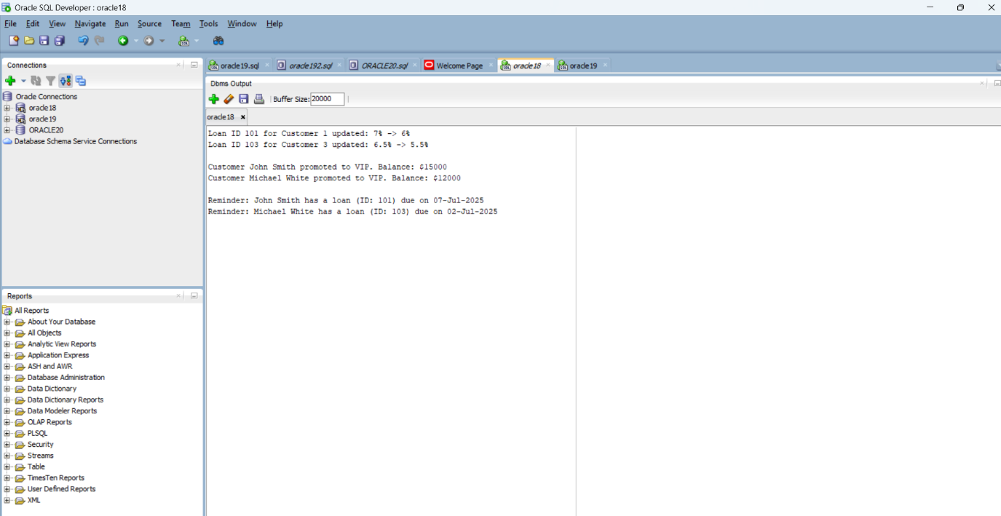

**Exercise 3: Stored Procedures**

# Tables created

-- Savings Account Table

CREATE TABLE savings_accounts (

account_id NUMBER PRIMARY KEY,

customer_id NUMBER,

balance NUMBER(12,2)

);

-- Employees Table

CREATE TABLE employees (

emp_id NUMBER PRIMARY KEY,

name VARCHAR2(100),

department_id NUMBER,

salary NUMBER(10,2)

);

-- Generic Accounts Table (for fund transfer)

CREATE TABLE accounts (

account_id NUMBER PRIMARY KEY,

customer_id NUMBER,

balance NUMBER(12,2)

);

**Scenario 1:**

CREATE OR REPLACE PROCEDURE ProcessMonthlyInterest IS

v_old_balance NUMBER;

v_new_balance NUMBER;

BEGIN

FOR acc IN (SELECT account_id, balance FROM savings_accounts) LOOP

v_old_balance := acc.balance;

v_new_balance := acc.balance + (acc.balance * 0.01);

UPDATE savings_accounts

SET balance = v_new_balance

WHERE account_id = acc.account_id;

DBMS_OUTPUT.PUT_LINE('Account ' || acc.account_id ||

' updated: ' || v_old_balance ||

' -> ' || v_new_balance);

END LOOP;

COMMIT;

END;

/

**Scenaio 2:**

CREATE OR REPLACE PROCEDURE UpdateEmployeeBonus (

p_dept_id IN NUMBER,

p_bonus_percent IN NUMBER

) IS

BEGIN

FOR emp_rec IN (

SELECT emp_id, name, salary

FROM employees

WHERE department_id = p_dept_id

) LOOP

UPDATE employees

SET salary = salary + (salary * p_bonus_percent / 100)

WHERE emp_id = emp_rec.emp_id;

DBMS_OUTPUT.PUT_LINE('Employee ' || emp_rec.name ||

' new salary: ' ||

(emp_rec.salary + emp_rec.salary * p_bonus_percent / 100));

END LOOP;

COMMIT;

END;

/

**Scenaio 3:**

CREATE OR REPLACE PROCEDURE TransferFunds (

p_source_acc_id IN NUMBER,

p_target_acc_id IN NUMBER,

p_amount IN NUMBER

) IS

v_source_balance NUMBER;

BEGIN

-- Lock and check source balance

SELECT balance INTO v_source_balance

FROM accounts

WHERE account_id = p_source_acc_id

FOR UPDATE;

IF v_source_balance < p_amount THEN

DBMS_OUTPUT.PUT_LINE('Transfer failed: insufficient balance.');

RAISE_APPLICATION_ERROR(-20001, 'Insufficient balance in source account.');

END IF;

-- Deduct and update

UPDATE accounts

SET balance = balance - p_amount

WHERE account_id = p_source_acc_id;

UPDATE accounts

SET balance = balance + p_amount

WHERE account_id = p_target_acc_id;

DBMS_OUTPUT.PUT_LINE('Transferred ' || p_amount ||

' from Account ' || p_source_acc_id ||

' to Account ' || p_target_acc_id);

COMMIT;

END;

/

# to get output this line need to br ececuted;

**EXEC ProcessMonthlyInterest;**

**EXEC UpdateEmployeeBonus(101, 10);**

**EXEC TransferFunds(1, 2, 500);**

**OUTPUT:**

